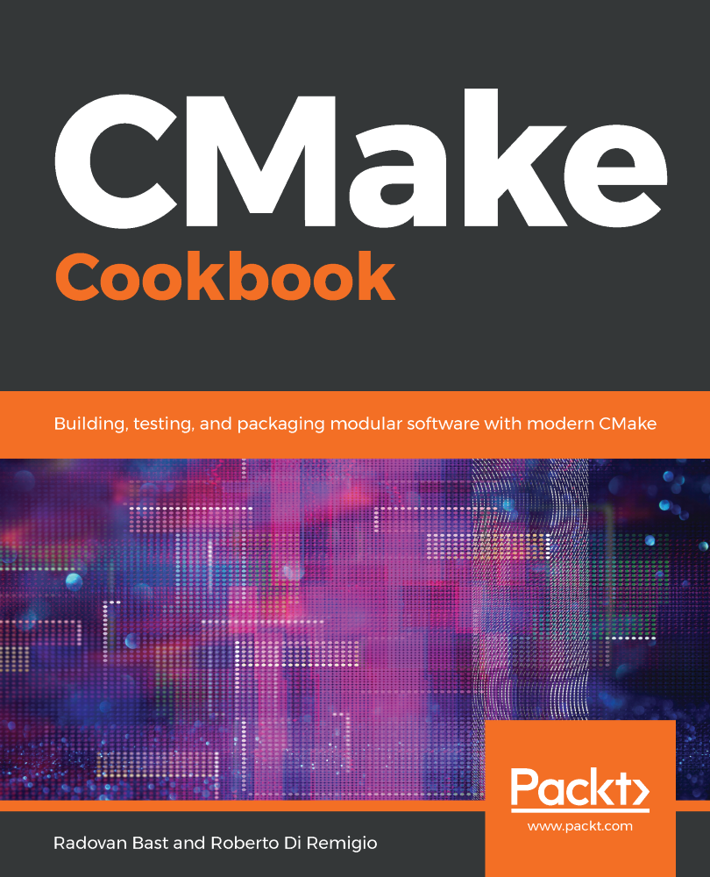

**CMake Cookbook**

Building, testing, and packaging modular software

with modern CMake

Radovan Bast Roberto Di Remigio



**BIRMINGHAM - MUMBAI**

# **CMake Cookbook**

Copyright © 2018 Packt Publishing

All rights reserved. No part of this book may be reproduced, stored in a retrieval system, or transmitted in any form or by any means, without the prior written permission of the publisher, except in the case of brief quotations embedded in critical articles or reviews.

Every effort has been made in the preparation of this book to ensure the accuracy of the information presented. However, the information contained in this book is sold without warranty, either express or implied. Neither the authors, nor Packt Publishing or its dealers and distributors, will be held liable for any damages caused or alleged to have been caused directly or indirectly by this book.

Packt Publishing has endeavored to provide trademark information about all of the companies and products mentioned in this book by the appropriate use of capitals. However, Packt Publishing cannot guarantee the accuracy of this information.

**Commissioning Editor:** Smeet Thakkar

**Acquisition Editor:** Noyonika Das

**Content Development Editor:** Francis Carneiro

**Technical Editor:** Sachin Sunilkumar

**Copy Editor:** Safis Editing

**Project Coordinator:** Devanshi Doshi

**Proofreader:** Safis Editing

**Indexer:** Pratik Shirodkar

**Graphics:** Jason Monteiro

**Production Coordinator:** Aparna Bhagat

First published: September 2018

Production reference: 1240918

Published by Packt Publishing Ltd.

Livery Place

35 Livery Street

Birmingham

B3 2PB, UK.

ISBN 978-1-78847-071-1

[www.packtpub.com](http://www.packtpub.com/)



Mapt is an online digital library that gives you full access to over 5,000 books and videos, as well as industry leading tools to help you plan your personal development and advance your career. For more information, please visit our website [mapt.io](https://mapt.io/).

# **Why subscribe?**

* Spend less time learning and more time coding with practical eBooks and Videos from over 4,000 industry professionals
* Improve your learning with Skill Plans built especially for you
* Get a free eBook or video every month
* Mapt is fully searchable
* Copy and paste, print, and bookmark content



**BIRMINGHAM - MUMBAI**